About AmazonSmile

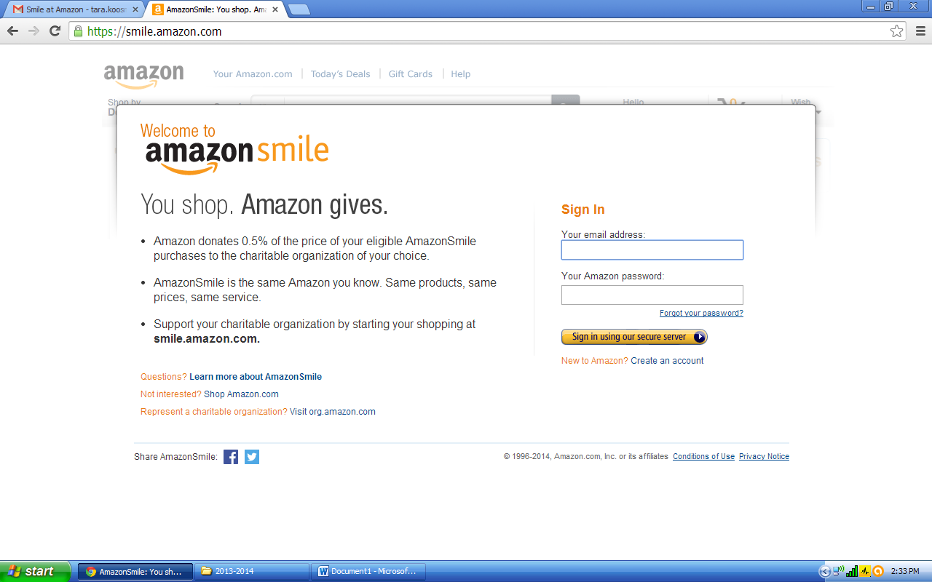
What is AmazonSmile?
AmazonSmile is a simple and automatic way for you to support your favorite charitable organization every time you shop, at no cost to you. When you shop at smile.amazon.com, you’ll find the exact same low prices, vast selection and convenient shopping experience as Amazon.com, with the added bonus that Amazon will donate a portion of the purchase price to your favorite charitable organization. You can choose from nearly one million organizations to support.
How do I shop at AmazonSmile?
To shop at AmazonSmile simply go to smile.amazon.com from the web browser on your computer or mobile device. You may also want to add a bookmark to AmazonSmile to make it even easier to return and start your shopping at AmazonSmile.
Which products on AmazonSmile are eligible for charitable donations?
Tens of millions of products on AmazonSmile are eligible for donations. You will see eligible products marked “Eligible for AmazonSmile donation” on their product detail pages. Recurring Subscribe-and-Save purchases and subscription renewals are not currently eligible.
Can I use my existing Amazon.com account on AmazonSmile?
Yes, you use the same account on Amazon.com and AmazonSmile. Your shopping cart, Wish List, wedding or baby registry, and other account settings are also the same.
How do I select a charitable organization to support when shopping on AmazonSmile?
On your first visit to AmazonSmile, you need to select a charitable organization to receive donations from eligible purchases before you begin shopping. We will remember your selection, and then every eligible purchase you make on AmazonSmile will result in a donation.
Can I change my charity?
Yes, you can change your charity any time. Your AmazonSmile purchases after the change count towards your newly selected charity. To change your charity, sign in to smile.amazon.com on your desktop or mobile phone browser and simply select “Change your Charity” in “Your Account.”
What charities can I choose from?
You can choose from almost one million eligible 501(c)(3) public charitable organizations.
What if my selected charity does not register to participate in the AmazonSmile program or becomes ineligible?
If an organization does not register to participate or becomes ineligible, you will have a chance to select a different organization or we will redistribute donations earned among other organizations receiving donations.
If I represent a charitable organization, how can I learn more about registering my organization for AmazonSmile?
Go to org.amazon.com to learn how to register your organization to receive donations.
How much of my purchase does Amazon donate?
The AmazonSmile Foundation will donate 0.5% of the purchase price from your eligible AmazonSmile purchases. The purchase price is the amount paid for the item minus any rebates and excluding shipping & handling, gift-wrapping fees, taxes, or service charges. From time to time, we may offer special, limited time promotions that increase the donation amount on one or more products or services or provide for additional donations to charitable organizations. Special terms and restrictions may apply. Please see the relevant promotion for complete details.
Can I receive a tax deduction for amounts donated from my purchases on AmazonSmile?
Donations are made by the AmazonSmile Foundation and are not tax deductible by you.
How can I learn more about AmazonSmile?
Please see complete AmazonSmile program details.

